Total Marks:
Obtained Marks:

LAB: Artifiical Intelligance

Lab Task # 01

Last date of Submission: Oct 8th, 2025

Submitted To: Mam Mutahra Khalid Butt
_______________________________________________________________________________________________________________________________________________________________________________________________________________________________________
Student Name: Ubaid Bin Waris
_______________________________________________________________________________________________________________________________________________________________________________________________________________________________________
Reg Number: 2212416
_______________________________________________________________________________________________________________________________________________________________________________________________________________________________________

Activity No.1

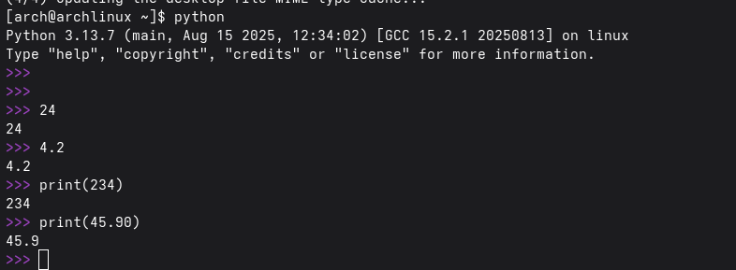

Activity no.2

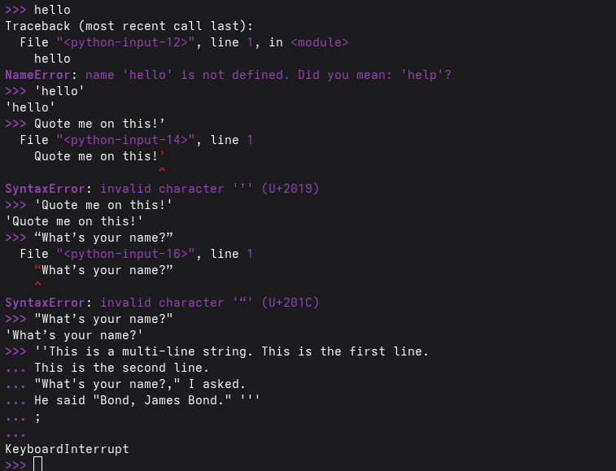

Activity no.3

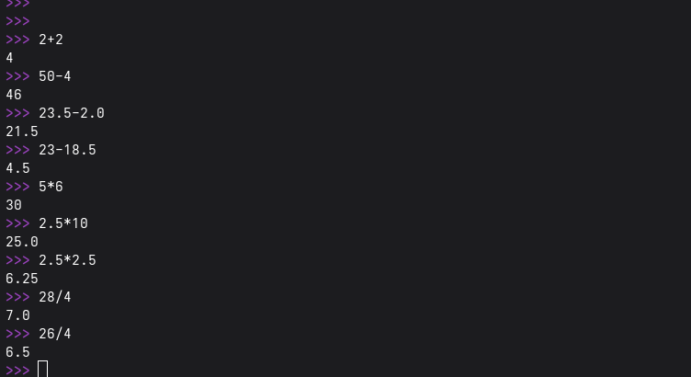

Activity no.4

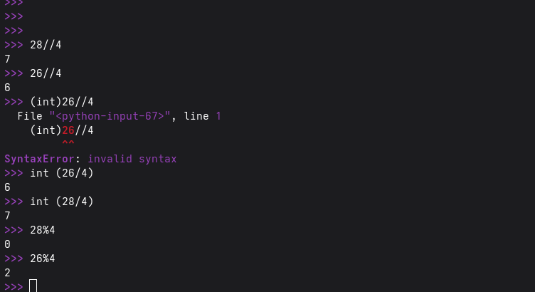

Activity no.5
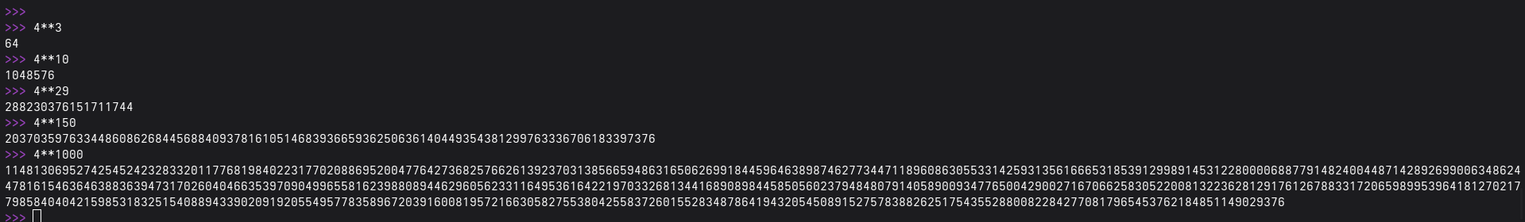

Activity no.6
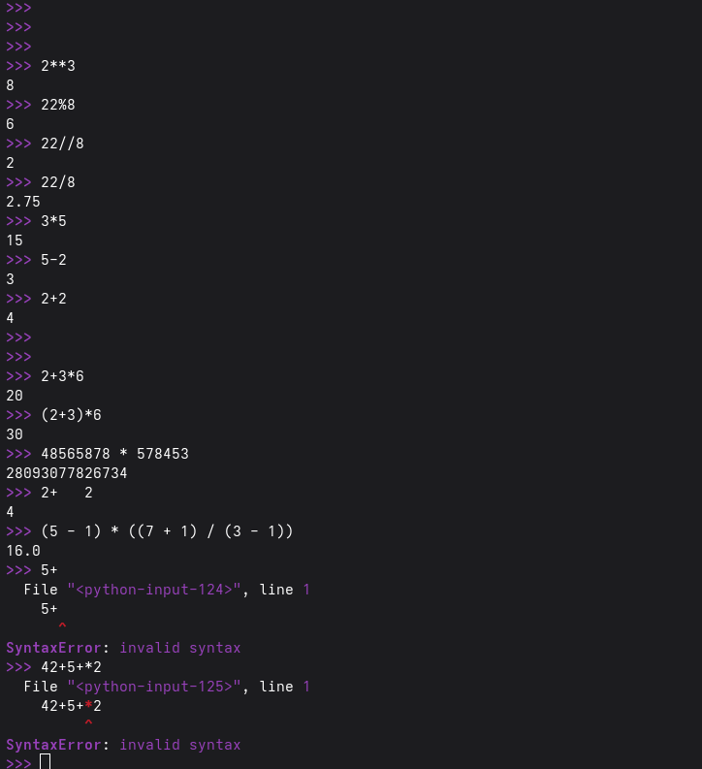

Activity no.7

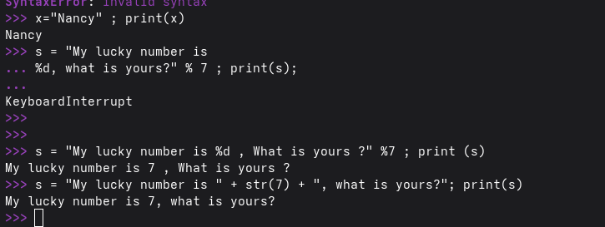

Activity no.8
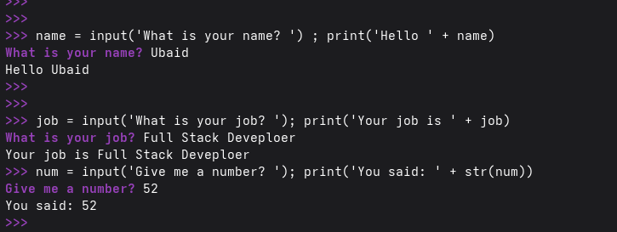

Activity no.9

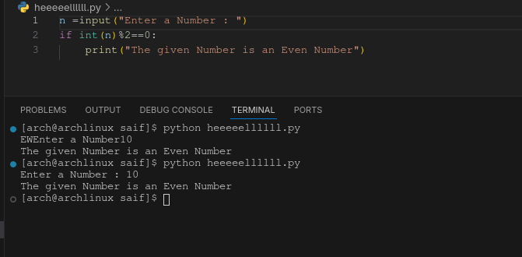

Activity no.10
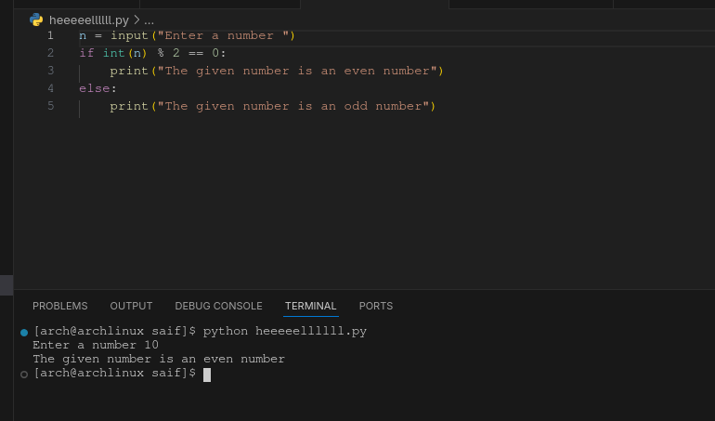

Activity no.11

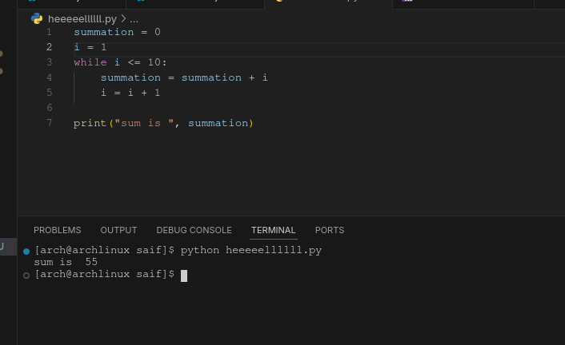

Activity no.12

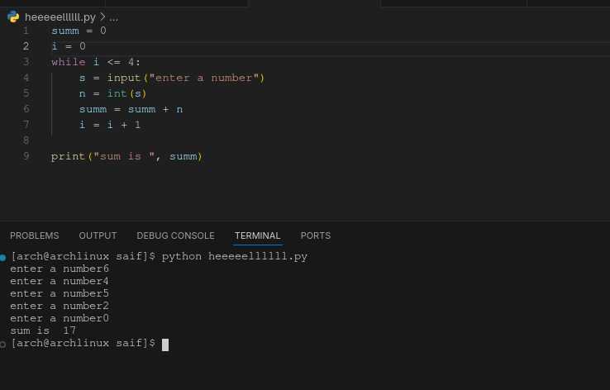

Activity no.13

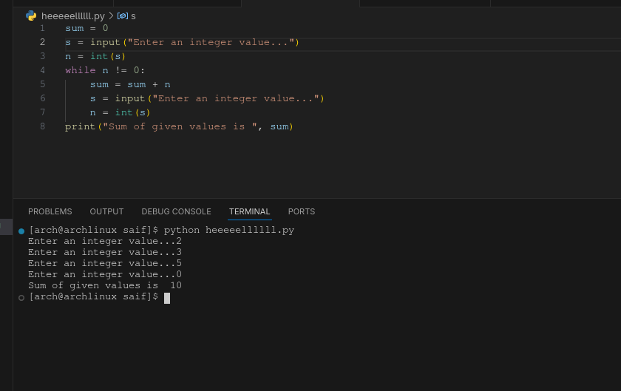

Activity no.14

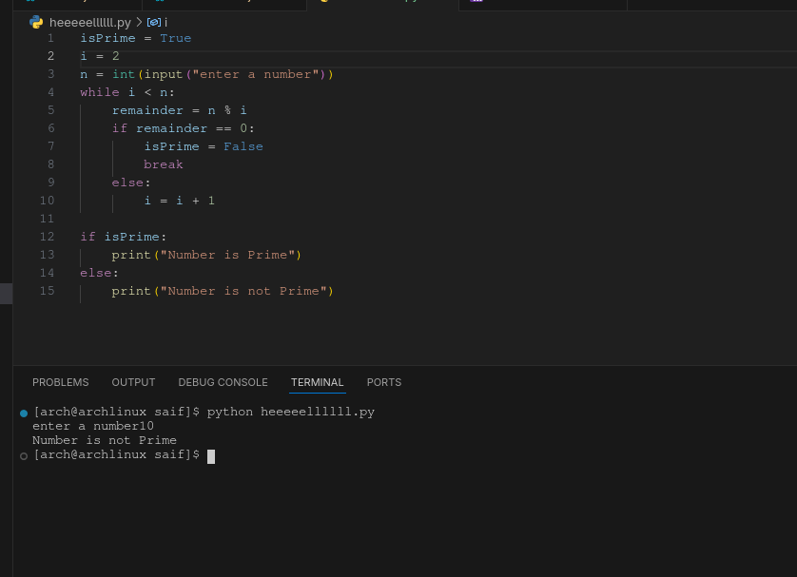

Task no.1

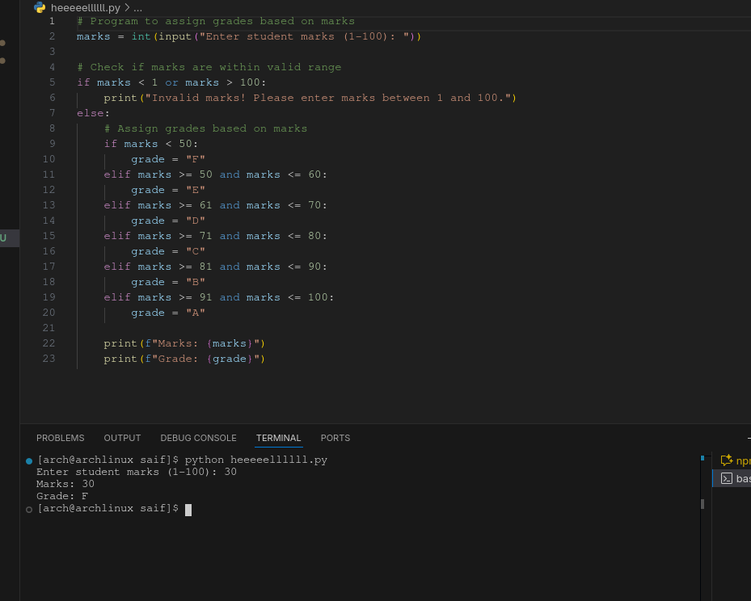

Task no.2

